LAKIREDDY BALI REDDY COLLEGE OF ENGINEERING
 | (Autonomous)
 | L.B.Reddy Nagar, Mylavaram – 521 230, Krishna (Dt.)
 | Ph: 08659-222933, 223936. Fax: 08659-222931
 | Email: lbcemym@lbrce.ac.in | Website: www.lbrce.ac.in
 | INFORMATION PERTAINING TO ADMISSION INTO FIRST YEAR
 | B.Tech. for “Category B seats” for the academic year 2015 – 16
1) | COURSES OFFERED
 |  |  |  | Category
Sl. | Branches |  | “Total intake” | ‘B’ Seats
1 | Electronics & Communication Engineering |  | 180 |  | 54
2 | Electrical & Electronics Engineering |  | 120 |  | 36
3 | Computer Science & Engineering |  | 120 |  | 36
4 | Mechanical Engineering |  | 120 |  | 36
5 | Information Technology |  | 60 |  | 18
6 | Electronics & Instrumentation Engineering |  | 60 |  | 18
7 | Aero Space Engineering |  | 60 |  | 18
8 | Civil Engineering |  | 60 |  | 18
2) NUMBER OF CATEGORY “B” SEATS

As per the Government Orders, category “B” seats are 30% of the “total intake” in each branch.

- ELIGIBILITY CRITERIA FOR ADMISSION INTO B.Tech. COURSE

Selection for admissions will be made strictly on merit basis in the following order (as per the guidelines laid down by A.P.S.C.H.E and Govt.of Andhra Pradesh.

  - NRI candidates

  - Candidates from other states and union territories of India, on the basis of ranks obtained either in the Common Entrance Test or AIEEE (JEE-main)
  - Candidates who secured at least 50% aggregate marks in the qualifying examination (10+2).

- BLANK APPLICATION FORMS

Candidates can obtain blank application form from the office of the college between 9.00 a.m. & 4.00 p.m. on all working days from 25-07-2015 to 31-07-2015.

- APPLICATION FORMS CAN BE DOWN-LOADED FROM WEB-SITE:

Candidates can download the application form the college website
www.lbrce.ac.in

- Photo copies of certificates to be submitted along with application form

  - Cash/D.D. for Rs. 2000/-

  - AIEEE/EAMCET – Rank Card
  - 10th Class (S.S.C.) certificate

  - Intermediate marks statements (1 & 2 year)

    - 1 -

7) FILLED-IN APPLICATION FORMS:

Filled-in application form has to be submitted with registration fee of Rs. 2000/- either in cash or by Demand Draft drawn in favour of Lakireddy Bali Reddy College of Engineering”, payable at Mylavaram.

8) LAST DATE OF SUBMITTING APPLICATIONS: On or before 31-07-2015

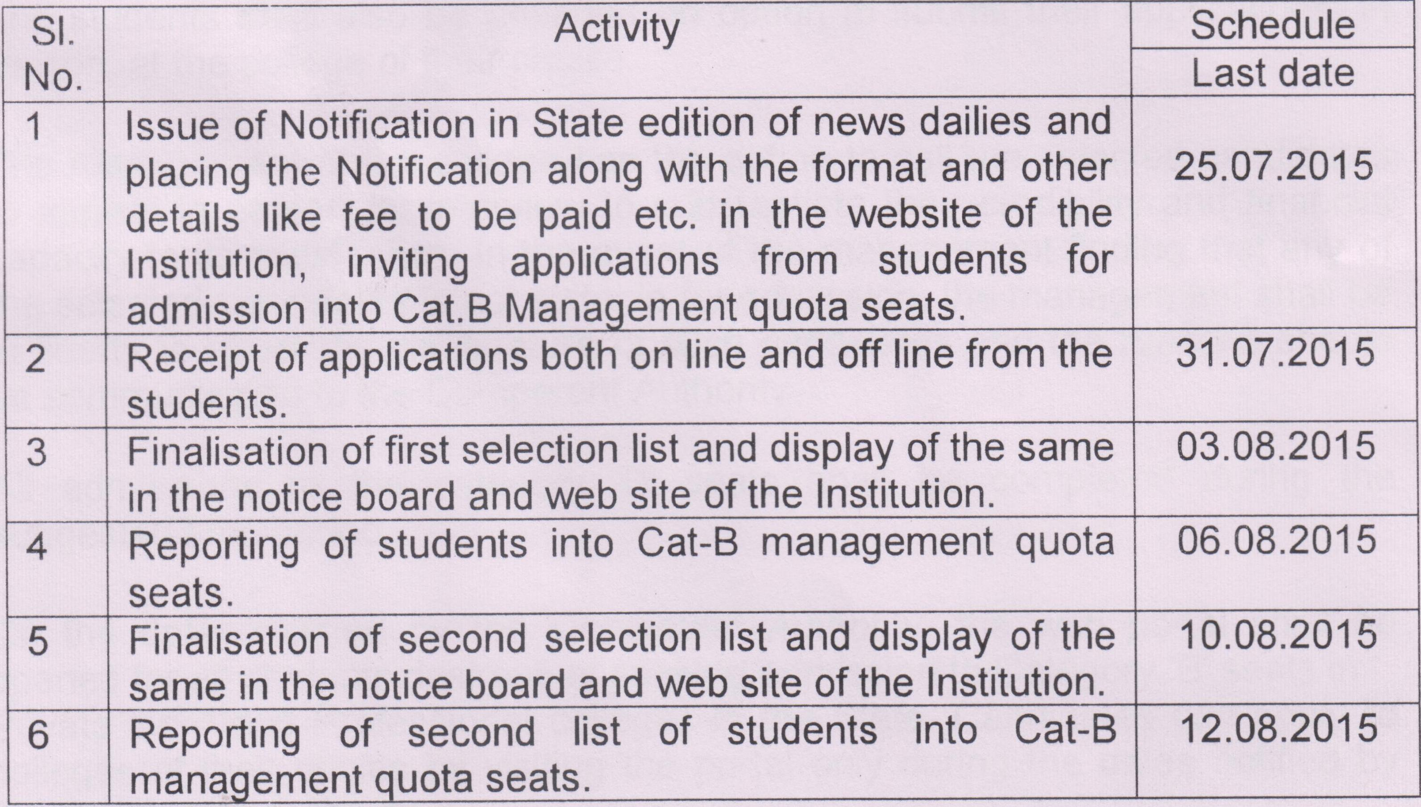

9) FEE PARTICULARS:

Maximum “tuition fees”, per year, as fixed by “Admission and Fee Regulatory Committee” for “Category B seats” is as follows:

Tuition Fee for all branches: 56,500/-* (Subject to the Government Order of
A.P.State Govt.)

At the time of admission, tuition fees shall be paid in full.

10) List of selected candidates will be displayed on notice board of the college and also in LBRCE website (www.lbrce.ac.in) on 03-08-2015.
11) The following documents are required at the time of admission

- Cash/D.D. for Rs. 2000/-

- AIEEE (JEE-Main) / EAMCET – Rank Card
- 10th Class (S.S.C.) certificate

- Intermediate marks statements (1 & 2 year)
- Transfer Certificate
- Conduct & Study certificate
- 4 pass-port size photographs

DIRECTOR

- 2 -

